WILL AMARON LAST LONG LIKE ITS BATTERIES..?

CONTENTS

Chapter No. | Name of the concept | Page No.
I | Introduction | 3
II | Amaron's Different Thinking | 8
III | Business Model & Joint Ventures | 17
IV | Marketing Strategies | 22
V | Key Financials | 27
VI | Future Ahead | 36
VII | References | 40

INTRODUCTION
To survive in today’s competitive world, for any company organization or firm relies upon its capacity to be dynamic and be distinct from the competition to gain upper hand in the industry. For this, it is imperative in knowing competitive and marketing procedures of an organization.
We have to comprehend and analyze strategic methodologies to make an interaction that will reach to the desired objective of an organization. Execution of marketing strategies encourages each company or business to keep the current clients and to built-up new clients. The present project is done to analyze the business strategies of Amaron Batteries, a product of Amararaja Batteries. The reason for this study is to examine whether the business strategies of the organization will assist it to cater to the requirements of coveted vision and mission.
The project analyses the different aspects of the company to
see if it is going in the right direction. The data is collected from different sources like journals, company websites and annual report of the company.

Amara Raja Group
Amara Raja is among India's top business conglomerates with business operations in different verticals, spanning from the production of lead-acid batteries (AMARON brand), power conversion and sheet metal products, electronic products, precision components, industrial services, and infrastructure development, to food processing. The primary company, named Amara Raja Batteries Limited, (which is under the Amara Raja Group of companies) is one of the biggest producers of Industrial and Automotive batteries in India. Amara Raja Group utilizes a workforce of in excess of 14,000 individuals with a net income of approximately Rs 7,755 Crores (USD 1.2 billion) in FY2017-18.
Amara Raja Batteries Limited
Amara Raja Batteries Limited is one of the biggest producers of lead-acid storage batteries for automotive and industrial applications in India. Its equity shares are listed on the National Stock Exchange of India Limited and BSE Limited. The Company's Industrial Battery business sells and supplies its products to customers, namely Railways, Telecom, Solar, Power Control, and UPS; and its Automotive Battery business supplies its products to Private Label Customers, OEMs, and Replacement Market.
The Company's products are sold to different countries in the Indian Ocean Rim. The Company also offers installation, commissioning and maintenance services. The company's principle industrial and automotive battery brands of the Company are Amaron®, PowerZone, Power Stack®, AmaronVolt and Quanta®.
Amara Raja started its business in the year 1985. The organization's Founder Chairman Dr Ramachandra N Galla has come back from the USA with the purpose of making a difference by introducing in his country at Chittoor District, Andhra Pradesh. He immovably trusted that apart from business goals, Entrepreneurs had a responsibility towards empowering individuals and propelling social objectives.
Amara Raja is a USD565 million Group, and is synonymous with modern engineering, and path breaking design and research. Each step of the company is focused towards manufacturing client-oriented products of high quality, right from design to manufacturing to sales and service. Partnerships and data sharing tie-ups with worldwide innovation pioneers likewise enable the organization to bring to you the best from around the globe.

Amaron batteries incorporate the most advanced technologies in the field of captive power and are at par with batteries manufactured and sold anyplace in the world. Thanks to a persistent focus on creative building, a profound commitment to design and research, and the promise to provide customer focused products, Amaron has ascended to a place of leadership in just a 7 years span.

The company offers a broad range of zero-maintenance batteries to its discerning Indian customers. The company has its top class, fully-integrated production facility in the sacred city of Tirupati, in Andhra Pradesh, India.

Top Management

Dr. Ramachandra Galla (Chairman) - From an agricultural family in the Chittoor district of Andhra Pradesh, Mr. Galla came back to his region after a long spell in USA. He had build his experience and expertise by working in top positions in the power and electrical industry in the US to control the green field ventures of Amara Raja Power Systems, other than Amara Raja Batteries.

Jayadev Galla (Managing Director) - Jayadev Galla worked for some time as an International Sales Executive for GNB Battery Technologies, Inc, USA, post completion of his education in the US. Later on, he worked as a management executive at Amara Raja Batteries in 1992, from where he has developed to assume control as the Managing Director in 2003. Jayadev Galla is also a Member of Parliament.

The experience of the top management combined with the joint ventures with the major companies in the world helps the company to effectively penetrate into the market.

AMARON'S DIFFERENT THINKING

Subsequent to putting in decades overlooked as a dark spot in the engine, the automotive battery has at long last discovered a place in the psyches of demanding customers, thanks to Amaron Batteries. It was a change whose time had come. The striking dark looks were only a sign of the progressions that had occurred. Since the genuine changes were inside the battery. It was the innovation that stamped Amaron as the cutting edge battery that would last longer than anything the Indian customer had seen.

At Amaron, the organization set out to change the customers' experience with batteries, and to discredit all the assumptions about batteries. For instance, the organization was the first to present a zero-maintenance battery, so you never needed to stress over other maintenance or top-ups. Amaron is also the only battery that left the production line completely charged. This implies that batteries were not subject to conflicting charging at the dealerships. So clients could rest guaranteed that all Amaron batteries were made equivalent and would perform the same.

The greatest change that the organization bought was the long life of the battery. The organization backed its innovation guarantee with its actions. Amaron is the main organization that had the confidence to offer the longest guarantees for batteries. Amaron was the first to offer three year, four year and multi month guarantees for auto batteries, which was twice the length of the guarantee time frames in the market. Moreover for two wheelers, the organization ensured that the rides were never felt regret. Amaron is the unique battery for bikes that offers a five year guarantee. The distinction is silver. Amaron is the main battery that contains the patent protected Silver X composite. What's more, that is the thing that enables it to keep going long, extremely long.

With Amaron, the progressions did not stop with the manner in which batteries were made. The company’s consistent endeavor to upgrade the client experience, the organization altered the retail and administration perspectives also. The organization's immaculate arranged retail outlets changed the manner in which you purchased a battery. Not any more grimy sheds and oily workshops. Battery shopping really turned into a delight. Amaron additionally ensure that you are never too far from it, on the grounds that the organization has the widest dealers network.
Additionally, the organization's 27/7 customer care guarantees peace of mind, since you know you can rely upon it, at anytime. Currently, there are around 13,500,000 Amaron batteries powering Indian vehicles.

Amaron Battery Specialties

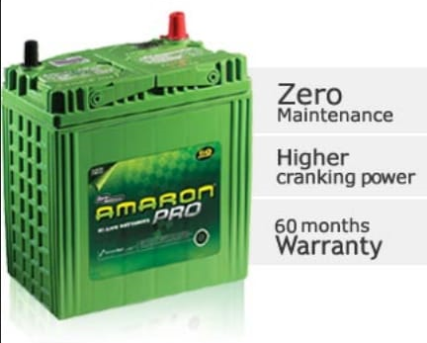

Key Facts:
- Amaron is the top promising company in India and is included on India's Forbes super 50 organizations.
- Currently, there are more than 13,500,000 Amaron batteries fueling Indian vehicles.
- Five Amaron batteries were being fitted every five minutes in vehicles in India (excluding two wheelers).
- The Taj Mahal, one of the Seven Wonders of the World, is fueled by Amazon.
- Each of the second telecom towers is powered by Amaron in India.
- Each third auto is fueled by Amaron in Singapore.
- Amaron batteries are used in defense industry widely.

Manufacturing

Amaron batteries are made in TS 16949 and QS 9000 IS 14000 ensured plants utilizing world-class innovation. The used raw materials are of best-in-class immaculateness and the organization never compromises on the quality. Each item is thoroughly tested according to a set of specifications. Amaron batteries are made in a completely mechanized assembly system, to ensure high quality products are manufactured. The completed batteries additionally experience stringent quality control parameters to ensure they meet worldwide standards, and will last long.

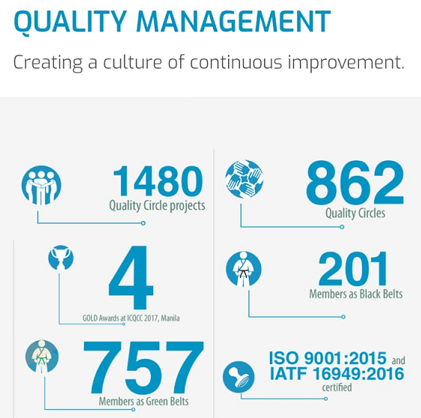



Awards & Recognition

- Included in Forbes Magazine's August 2017 issue, India's Super 50 Companies for the second time in succession.
- Accorded First Award under the classification "Private – Manufacturing (Large)" at the fourteenth National Awards for Excellence in Cost Management 2016 from The Institute of Cost Accountants of India.
- Awarded the "Reliably High Quality Performance" and "Outline and Development" grants from Maruti Suzuki India Ltd.
- Bestowed with the Quality honor from Tata Motors Limited in acknowledgment for greatness in the field of QCDM parameters (Excellence in Delivery, Quality, and relationship Building)
- Obtained the Q1 award from Bajaj Auto Limited in acknowledgment for greatness in the field of QCDM parameters (Excellence in Quality, Delivery, and relationship Building).
- Awarded the "General Performance" from Bosch Limited Bangalore.
- Cummins India Limited awarded the company with "Ecological Leadership".
- Received the 'Best-in-class Supply Chain Innovation Award' at the Asia Logistics and Supply Chain Leadership Conclave held at Mumbai.
- Received the first runner award at the Eleventh CII Six Sigma National Conference and Competition under the "Assembling Industry (Discrete and Assembly Line)" classification.
- Presented with renowned ABK AOTS awards in following three unique classes
- Accorded model 5S Company award for Automotive Battery Plant, Tirupati and MVRLA Battery Plant, Chittoor
- Obtained 4 "Gold" honors at ICQCC (International Convention of Quality Control Circles) 2017 rivalry held in Manila, Philippines.
- Declared as the winner for its introduction on "Nava Prathibha - Talent working at the Entry Level" under the classification of "Best Recruitment, Engagement and Innovative Retention Strategy" at the CII - First National HR Circle Competition
- Obtained "Gold award" under infra gear's segment from Indus Towers Limited.

BUSINESS MODEL & JOINT VENTURES

Joint Venture with Johnson Controls

Amara Raja Batteries is a division of a worldwide supply alliance, comprising Johnson Controls Inc, Varta AG of Europe and Enertec of Mexico. Johnson Controls holds 26% stake in Amara Raja Batteries. Amara Raja Batteries has completed 20 year of alliance with Johnson Controls, an exceptionally captivating and enhancing journey which changed Amara Raja from simply one more battery maker into an industry innovator. Amara Raja Batteries, in a joint effort with Johnson Controls Inc., USA, is the biggest producer of Standby VRLA (Valve Regulated Lead Acid) batteries in the Indian Ocean Rim.

Automotive & Automobile Batteries

Amara Raja offers automotive batteries to all vehicle manufactures in the country, such as Hyundai Motors India Limited, Maruti Suzuki India Limited, Tata Motors Limited, Ford India Limited, Mahindra and Mahindra Limited, General Motors Limited Honda Siel Cars India Limited.

The organization is glad to be a select provider to various prestigious projects of original equipment manufacturers, such as Maruti Suzuki A -Star, Mahindra SUVs, ATA ACE micro hybrid model, and Hyundai EON. The company has a market share of 25 % of passenger vehicles and 43% in commercial vehicles.

Exports Segment - Amaron Batteries India

Amara Raja Batteries is ready to be a worldwide player in the coming years, as it is in the quest for development and extension of its business apart from Indian shores. Amaron's automotive batteries reach customers in excess of 25 nations, with a presence in the Middle East, Africa, East Asia, and Australia.
Having fabricated an impressive business and brand in India, the organization is setting up a reputation for the Amaron brand in the international market for quality and execution. The organization's objective is to become a worldwide company with world-class building abilities, cutting edge manufacturing facilities in India and abroad, and a worldwide client base.

The organization's devoted investments in Engineering and R&D have resulted in enhanced technological capacities and extensive product range for customers over the globe. Amaron has proved to be the only battery that has double the existence when contrasted with different batteries even in the dry and moist desert conditions of Northern Australia. By ethicalness of its unrivaled quality, Amaron has likewise made an entry in Japan, where stringent Quality and Technology are central.

Amaron Market

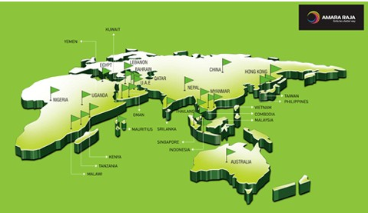

Private Label Segment - Amaron Batteries

The organization's Private Labeling business was hailed off in 2001 with a view to increase its business share in India's organized battery segment. Amara Raja and Johnson Control USA wandered into private labeling with Bosch silver batteries. By the consequent year, the organization had started to produce, brand and offer GM's AC Delco range of automotive batteries, namely Lucas Endura and Pacer Batteries.

The company also produces batteries for Cummins, the biggest engines manufacturer for automobiles in India. In addition, the company produces batteries for Luminous Power Technologies (P) Ltd, the premier company offering high quality power solutions for homes today.

MARKETING STRATEGY

There has been a renewed focus around improving the proficiency of lead acid batteries by offering technological advanced products to clients. Consequently, developing batteries of high quality is emphasized, which are long-lasting with low - maintenance. AGM (Absorbent glass mat) innovation is one of the most recent technologies launched in India. This technology is productive, offers ideal execution in extraordinary cycling applications, with both high-charge acknowledgment and fractional condition of-charge operations.

Amaron's tubular facility which is newly commissioned is operating at maximum capacity with respect for the entire year. The organization is adding one more line to this facility to expand its ability by 0.4 million batteries. Having included more customers and more vehicle stages of existing customers, the organization is setting up extra lines for assembling 4-wheeler batteries, therefore taking its aggregate capacity to 12.8 million batteries.

Having made its entry into the two wheeler market with various products, the organization set up a very complex, completely coordinated facility (with a capacity of 17 million batteries) for two wheeler batteries to be charged in a phase by phase manner – Phase I for assembling 5 million batteries was dispatched in December 2017. These new limits are required to be commissioned in the present year, which, when commissioned, signify to catalyze business execution.

The Government's monetary inclusion drive has brought about noteworthy penetration of the saving banking sector in rural India. To give a dependable power back-up for rural banking, the company propelled a tubular overflowed battery variant, modified to the prerequisite of this application. This advancement had opened a totally new market space for Amara Raja.

Indeed, even as the Government stays enduring on its objective of embracing the BS-VI standards by 2020, the organization understood that the battery necessity for passenger cars would change. With regards to this knowledge, Amaron built up the powerful Enhanced Flooded Battery for Idle-Start-Stop applications, which are as of now experiencing field preliminaries with select OE clients.
Furthermore, there is a whole other world to this – Amaron is likewise building up an unrivaled battery variant for Advanced, Start-Stop applications which ought to be introduced soon. The organization made an invasion into motive power; for this is a sunrise sector n which is at an affectation point in its trip – its development being catalyzed by great government strategies and significant investments by the private segment in new-age warehousing arrangements. The organization is seeding the market with batteries imported from Europe before setting up its office.

The organization is quietly tuning in to the buzz around e-portability from all quarters as this includes venturing into the much discussed lithium-ion space. What's more, even as the organization concentrated on drawing up a technique from the entire clamor, it has made infant strides in the e-mobility space. The organization has built up a battery (utilizing the lead-acid stage) to e-rickshaw applications which, throughout the years, have picked up prominence in people in public transport spine in urban communities and towns crosswise over India. Moreover, even as the organization ponder on foraying into lithium-ion batteries, the organization has set up a battery pack get together unit , which ought to be operational soon.

All that really matters at Amara Raja, the fervor is unmistakable. As should be obvious various things are going on in the meantime – more frameworks, more items, more innovation, more verticals and more clients. The main issue at that point is – the organization are grabbing the day, to develop better tomorrow; the organization is fortifying its center to make the business operations more adaptable. Also, as it is attempting to break out of the difficulties that held back earlier, sectoral tailwinds should quicken business growth.

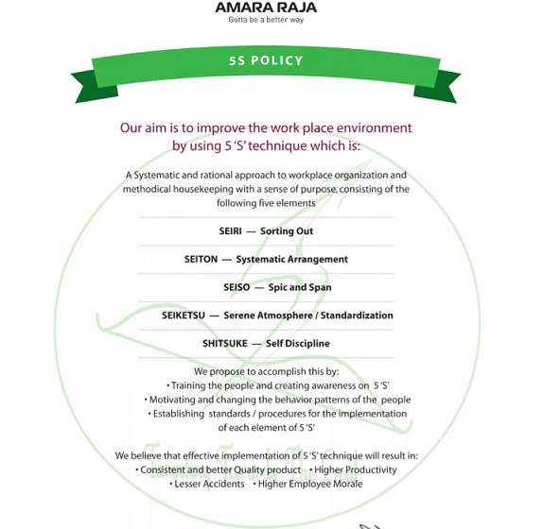

KEY FINANCIALS
Net Sales
Table 1: Net Sales (Cr Rs)
Year Ending | 2018 | 2017 | 2016 | 2015 | 2014
Net Sales | 6051 | 5335 | 4633 | 4211 | 3437

The net sales of the company have been gradually increasing for the last five years. The sales of the company have increased from Rs.3,437 Crores in 2014 to Rs.6,051 Crores in 2018.
Figure 1: Net Sales (Cr Rs)

Profit After Tax
Table 2: Profit After Tax (Cr Rs)
Year Ending | 2018 | 2017 | 2016 | 2015 | 2014
Profit After Tax | 471 | 478 | 492 | 411 | 367

The profits after tax have been steady for the last five years. The company reported a profit after tax of Rs.471 Crores in 2018 compared to Rs.367 Crores in 2014.
Figure 2: Profit After Tax (Cr Rs)

Earnings Per Share
Table 3 : Earnings Per Share ( Rs)
Year Ending | 2018 | 2017 | 2016 | 2015 | 2014
Earnings Per Share | 27.59 | 28.01 | 28.78 | 24.05 | 21.51

The EPS of the company has been consistent for the last three years. The EPS has increased from Rs.21.51 in 2014 to Rs.27.59 in 2018.

Figure 3 : Earnings Per Share (Rs)

Share Price (Rs)

Table 4: Share Price (Rs)
Year Ending | 2018 | 2017 | 2016 | 2015 | 2014
Share Price | 800 | 800 | 1020 | 985 | 600

The share price of the company has increased from Rs.600 in 2014 to Rs.1020 in 2016, but has fallen down to Rs.800 in 2018 inspite of the markets increasing in the last two years.

Figure 4: Share Price (Rs)

EBITDA (Crores in Rs)

Table 5: EBITDA (Crores in Rs)
Year Ending | 2018 | 2017 | 2016 | 2015 | 2014
EBITDA | 929 | 878 | 849 | 724 | 576

The EBITDA of the company has been consistently increasing over the last five years. The EBITDA of the company increased from Rs.576 Crores in 2014 to Rs.929 Crores in 2018.

Figure 5: EBITDA (Crores in Rs)

Net Cash from Operations (Crores in Rs)

Table 6: Net Cash from Operations (Crores in Rs)
Year Ending | 2018 | 2017 | 2016 | 2015 | 2014
Net Cash from Operations | 322 | 553 | 555 | 395 | 279

The net cash from operations for the company have increased in the last four years, but the same has decreased in 2018. The net cash from operations has decreased from Rs.553 Crores in 2017 to Rs.322 Crores in 2018.

Figure 6: Net Cash from Operations (Crores in Rs)

Net Worth (Crores in Rs)

Table 7: Net Worth (Crores in Rs)
Year Ending | 2018 | 2017 | 2016 | 2015 | 2014
Net Worth | 2937 | 2593 | 2116 | 1700 | 1363

The Net Worth of the company has been consistently increasing in the last five years. The Net Worth of the company increased from Rs.1363 Crores in 2014 to Rs.2937 Crores in 2018.

Figure 7: Net Worth (Crores in Rs)

Net Fixed Assets (Crores in Rs)

Table 8: Net Fixed Assets (Crores in Rs)
Year Ending | 2018 | 2017 | 2016 | 2015 | 2014
Net Fixed Assets | 1703 | 1492 | 1352 | 944 | 623

The Net Fixed Assets of the company has been consistently increasing in the last five years. The Net Fixed Assets of the company increased from Rs.623 Crores in 2014 to Rs.1703 Crores in 2018.

Figure 8: Net Fixed Assets (Crores in Rs)

Net Current Assets (Crores in Rs)

Table 9: Net Current Assets (Crores in Rs)
Year Ending | 2018 | 2017 | 2016 | 2015 | 2014
Net Current Assets | 1105 | 857 | 745 | 766 | 695

The Net Current Assets of the company has been consistently increasing in the last five years. The Net Current Assets of the company increased from Rs.695 Crores in 2014 to Rs. 1105 Crores in 2018.

Figure 9: Net Current Assets (Crores in Rs)

FUTURE AHEAD

Marketing strategies serve as the principal underpinning of marketing plans that are intended to fulfill market needs and achieve marketing goals. Plans and goals are basically tested for quantifiable outcomes. Usually, marketing strategies are developed as multi-year designs, with a strategic plan itemizing particular activities to be accomplished in the present year. Time horizons that are covered by marketing plan differ by organization, by industry, and by country, nonetheless, time horizons are getting to be shorter as the speed of progress in the environment is increasing.

Marketing methodologies are dynamic and intuitive. They are partly planned and partly unplanned. Marketing strategy needs to take a long haul view, and tools such as client lifetime esteem models can be intense in reproducing the impacts of strategy on acquiring, revenue per client and beat rate. Marketing strategy includes cautious and thorough checking of the environments, both internally and externally. Amaron Batteries is well positioned in terms of setting up and executing its marketing strategies in line with its predefined vision and mission.

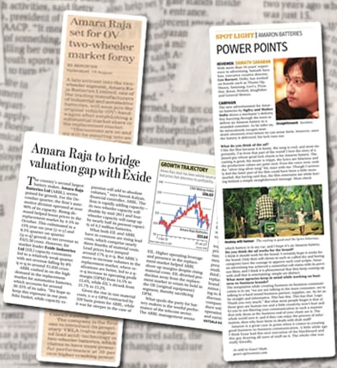

Lining up with the sectoral guarantee, Amara Raja's blue print consists of an expansion in manufacturing infrastructure. It intends to include two mechanical production systems for it four-wheeler batteries and one line for its UPS batteries for homes. Further, the Company will keep up adding capacity with regards to its two wheeler batteries to cater to the developing interest of two wheeler OE clients. Indeed, even as operating capacity is required to keep on increasing, the group will hone its control on enhancing shop floor efficiencies for advancing the Company's conversion costs.

Internal environment factors consist of the marketing mix and its modeling, in addition to analysis of the performance and key requirements. External environment factors comprise the analysis of competitor customer, and the target market, as well as the assessment of any elements of economic, technological, cultural or political environment which is likely to impact on the business success. A key part of marketing strategy is to keep marketing in accordance with an organization's mission statement. Amaron Batteries strikes a balance to keep its internal and external factors that affects it market. Within a span of just 7 years, the company has become a leading player in the market only next to Exide batteries which has been in existence for decades.

From a business improvement point of view, the Company is in advanced phases of correspondence with OEs in the passenger vehicle and two wheeler segments which hold the guarantee to increase sales volumes in the OE and post-retail space. In its undertaking to enlarge its horizon, the Company is additionally working effectively on building up its impression in the three wheeler battery space. With regards to the e-vehicle necessity which is high on the Government agendas, the Company is setting up an assembly unit which ought to encourage in building up a dependable balance in this high-potential sunrise business.

REFERENCES
https://www.amaron.in/aboutus.php
https://www.amaron.in/management.php
https://www.amaron.in/oem.php
https://www.amaron.in/manufacture.php
https://amararajabatteries.com/about.html#about-us
https://amararajabatteries.com/about.html#award
https://amararajabatteries.com/images/investors/annual-reports/Annual-Report-2017-18.pdf

